**Practical 7**

**VIRTUALIZATION**

**-Neha T Mathew A069**

**Ec2 for Ubuntu**

Go to search and type EC2 . Click on Launch instances

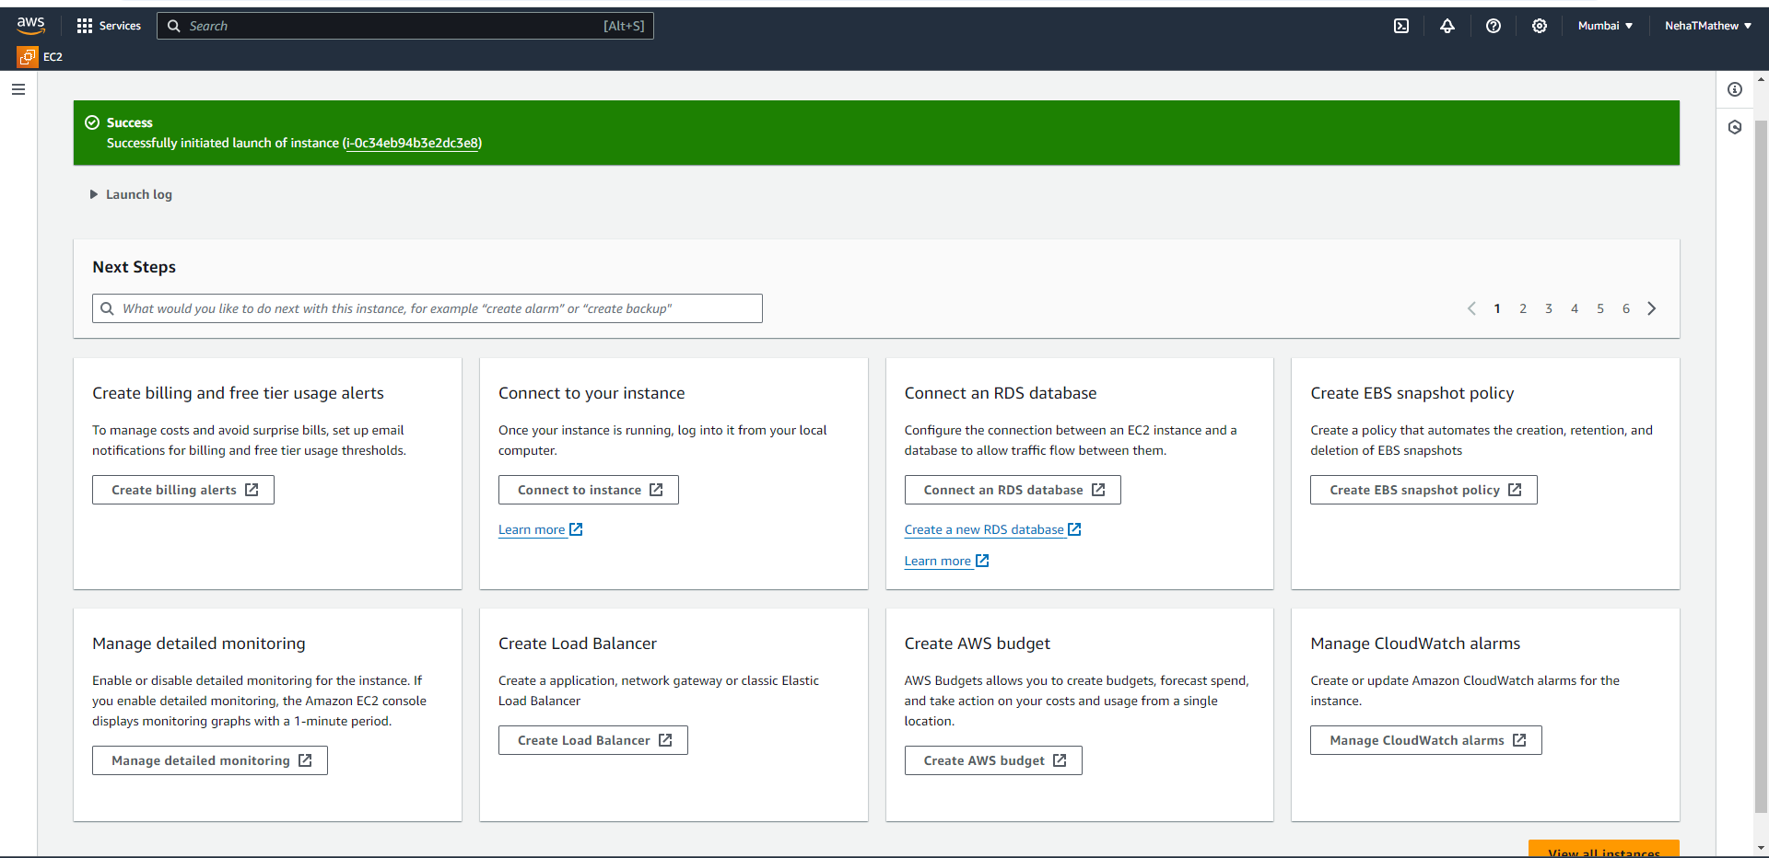

Create an instance name myec2 on Ubuntu

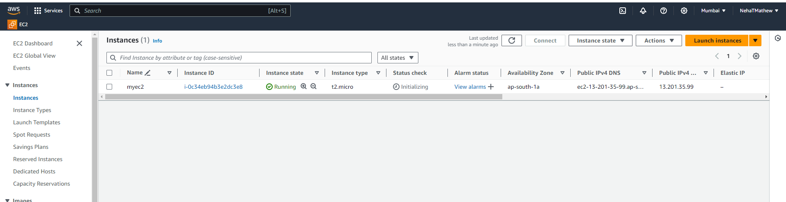

Now connect it

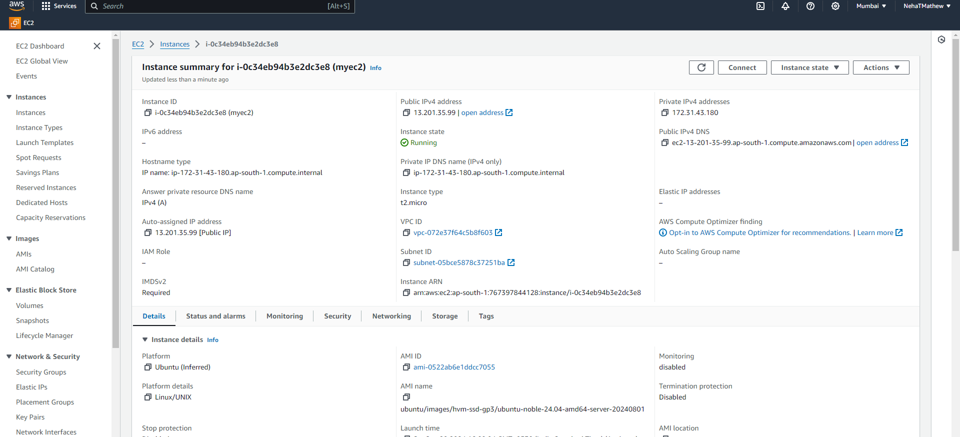

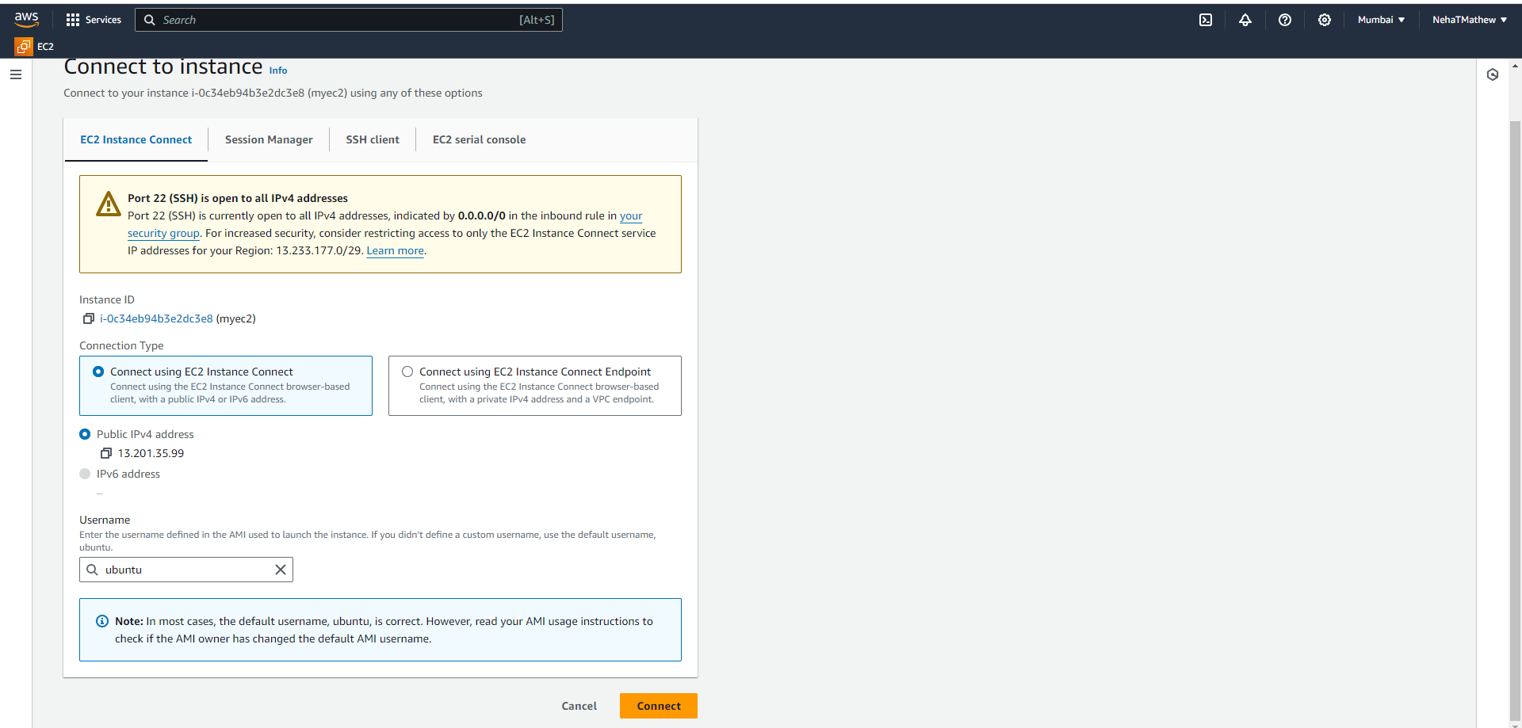

Instance has been launched

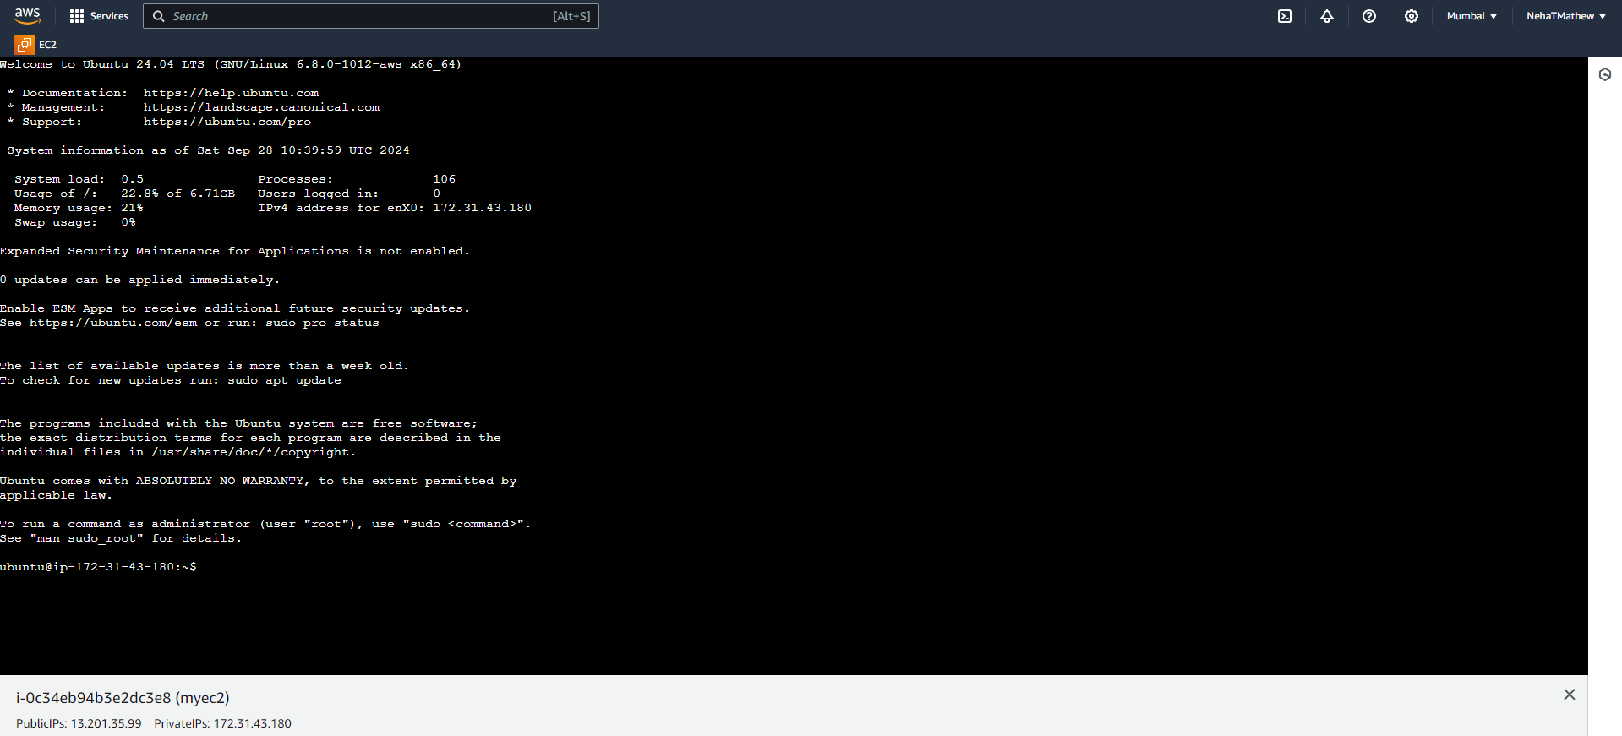

Go to MobaXterm click on SSH and copy paste the ip4 addreess in the instance summary on the remote host . them specify the username in tha blank below as “myec2”. Go to advanced SSH settings

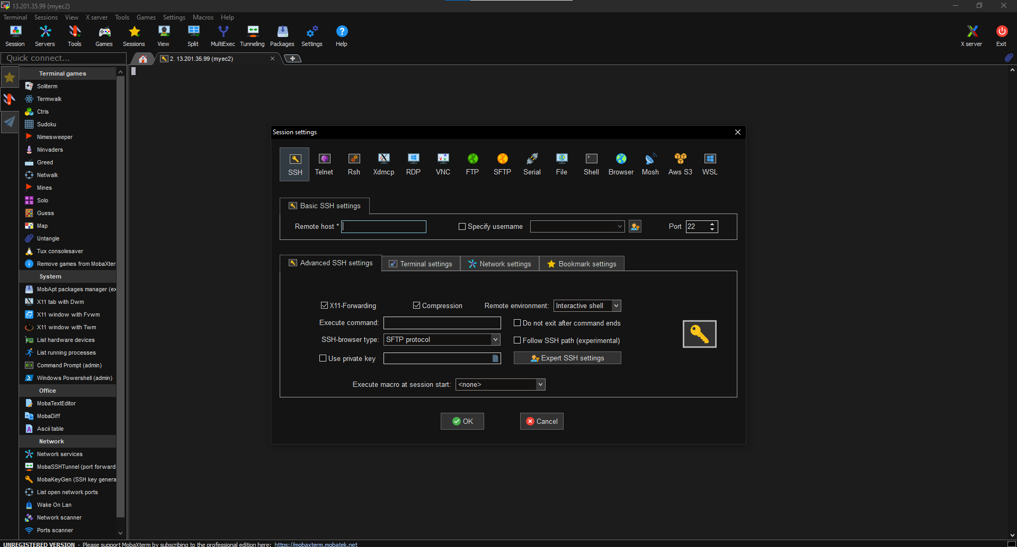

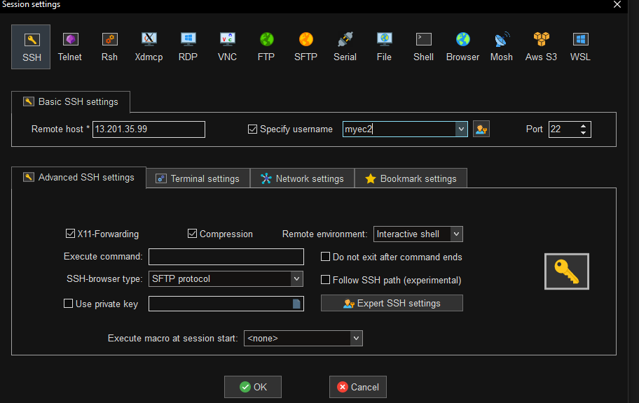

Tick the “use private key “ and browse the folders for the key download while launching the instance

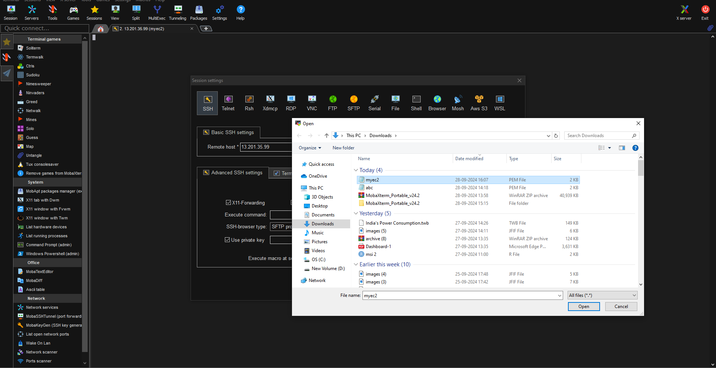

Click on Ok

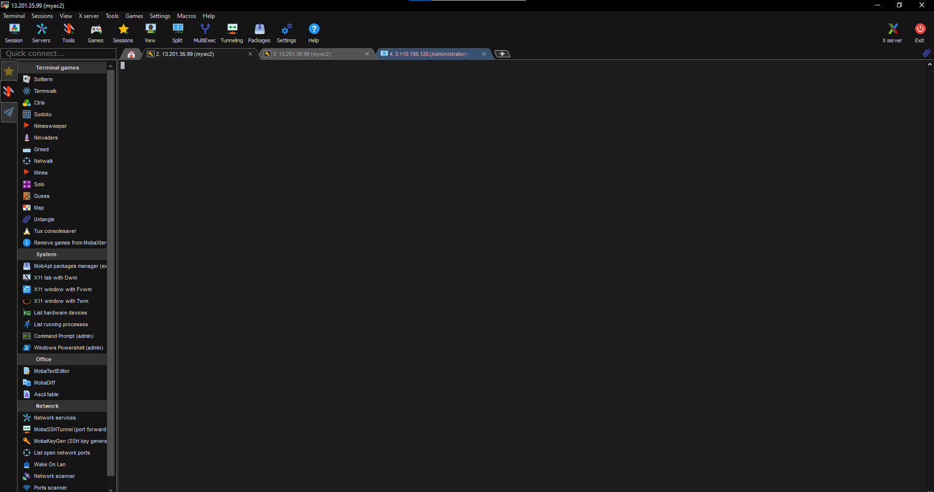

**EC2 for windows**

Perform the same steps for creating the instance but instead click on “windows”

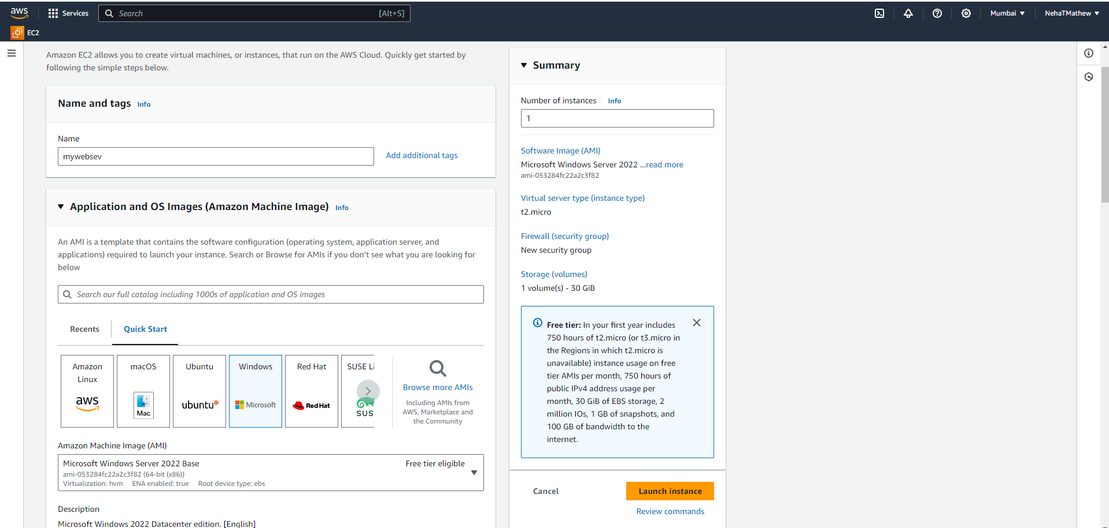

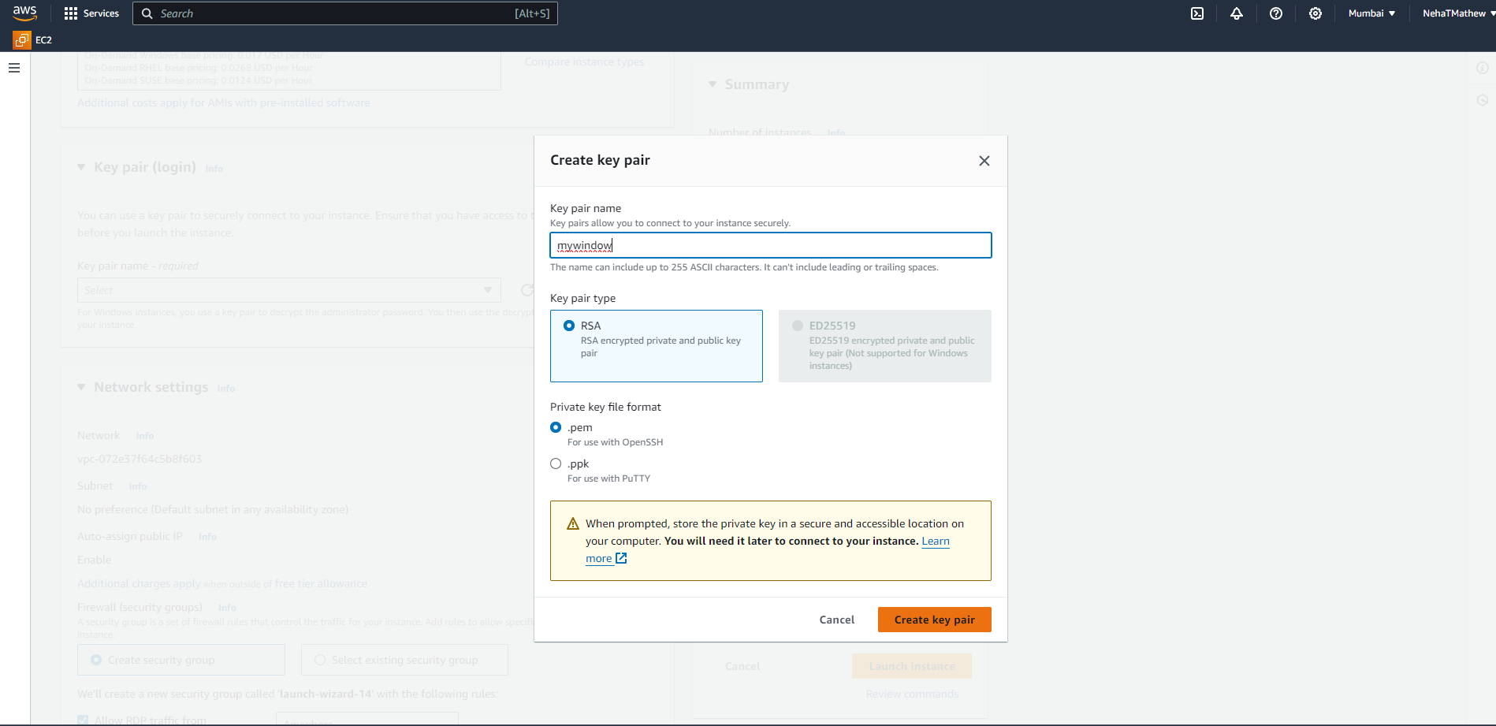

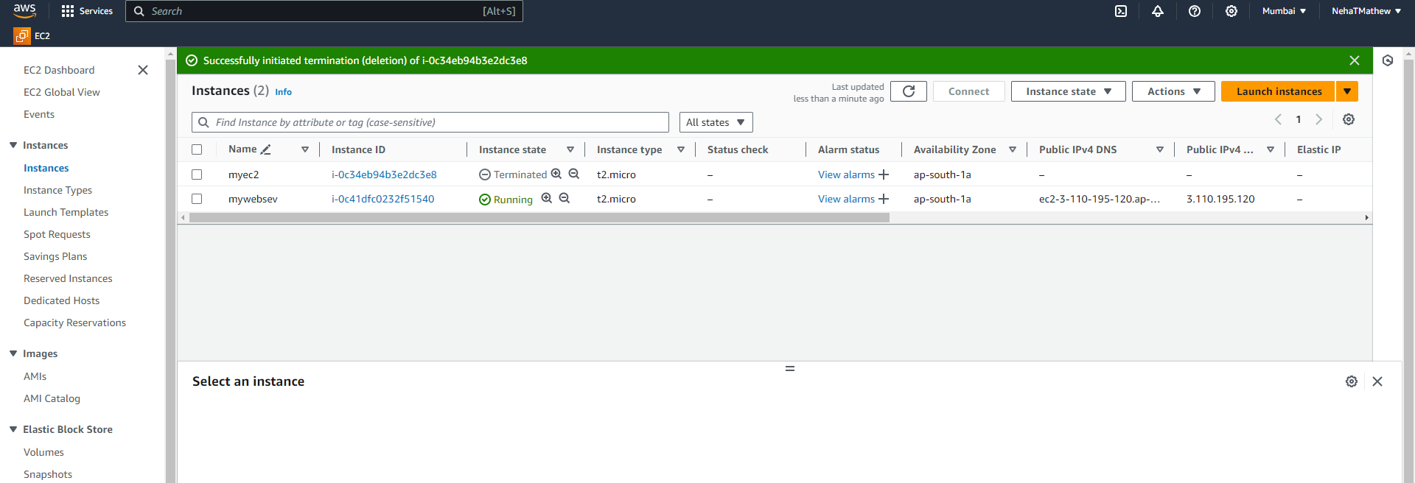

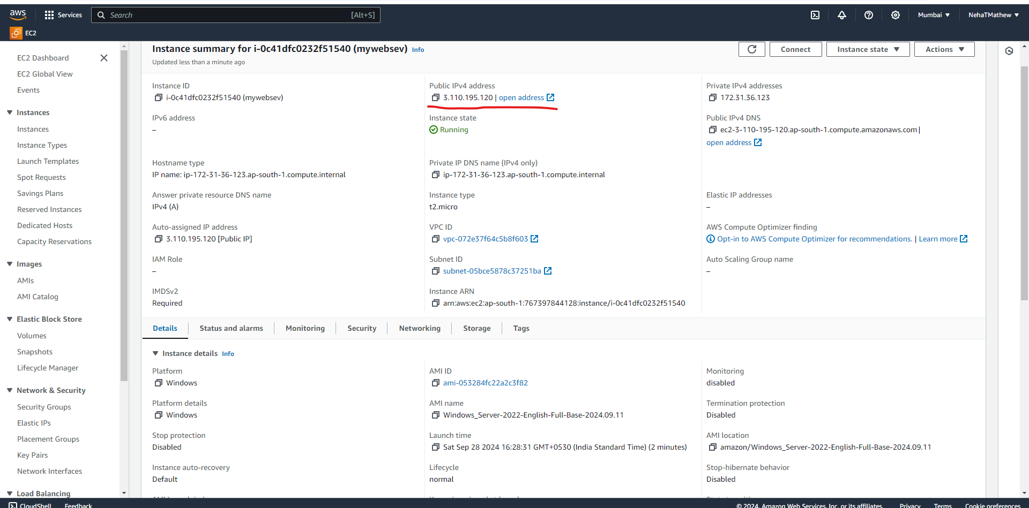

Copy the username “Administrator” and paste it on MobaXterm

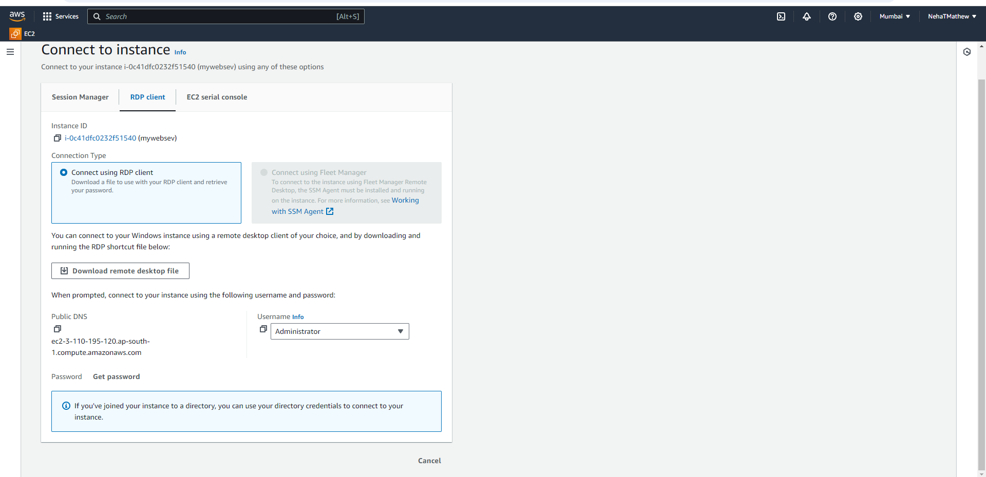

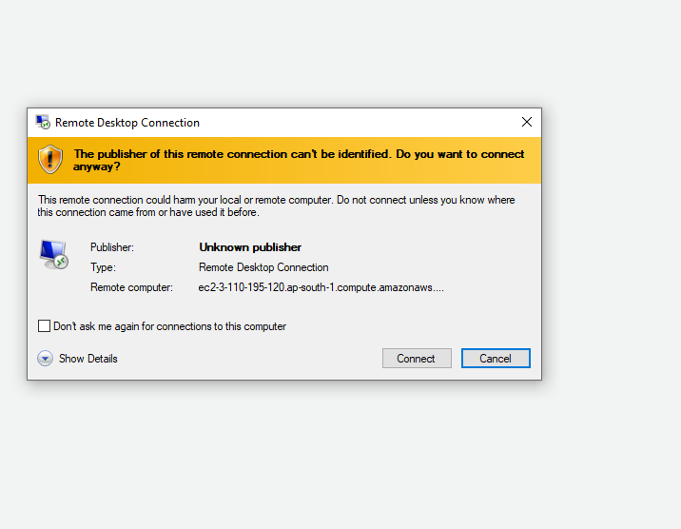

Click on upload private key

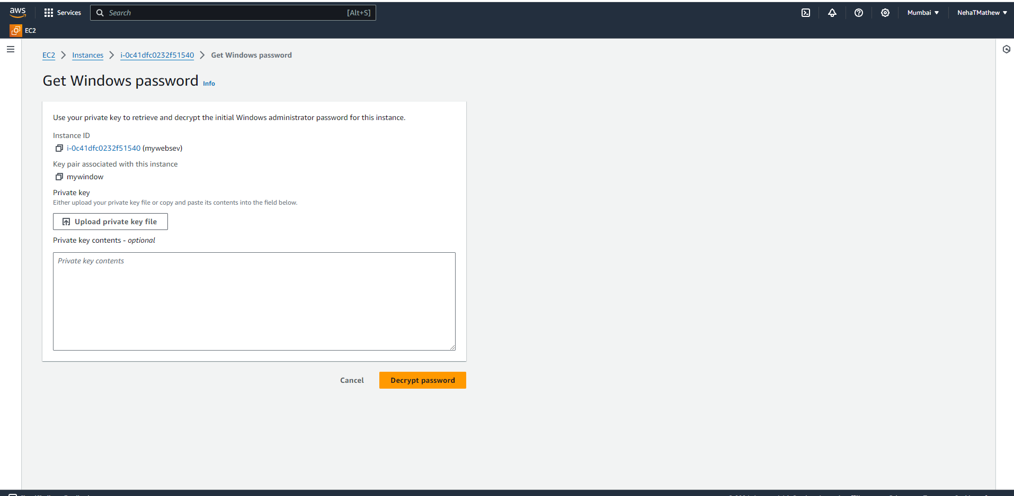

Upload mywindow key

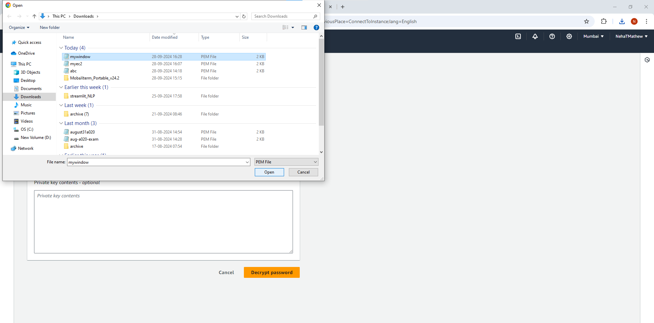

Click on decrypt password

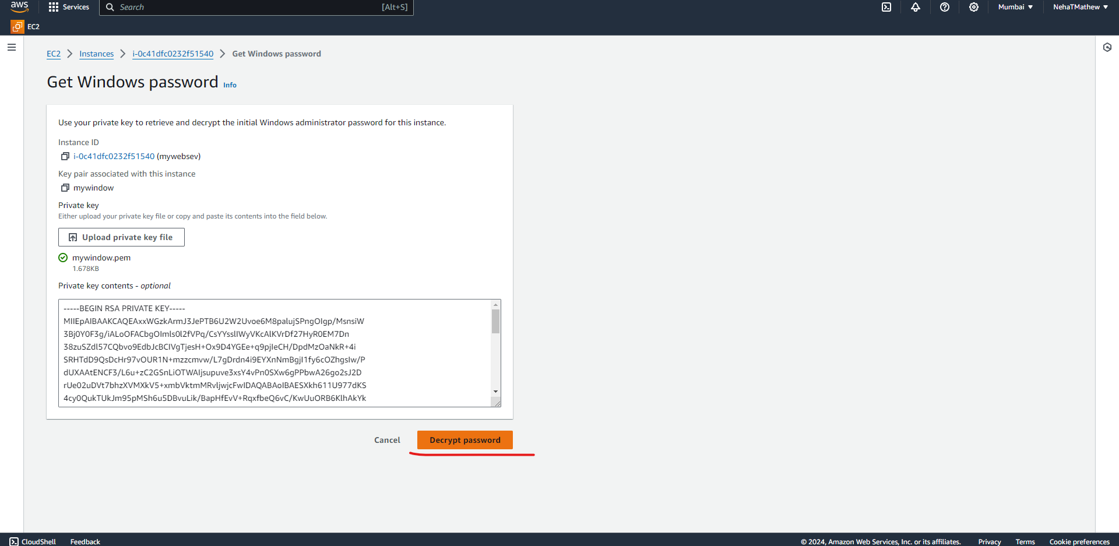

Copy paste the username “Administartor and paste it on MobXterm

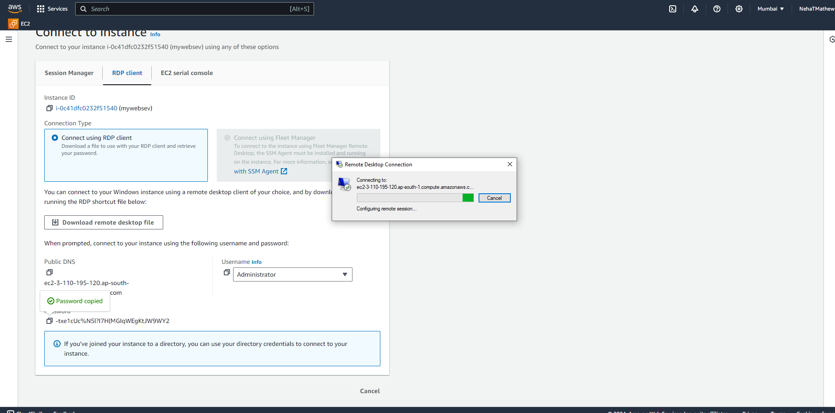

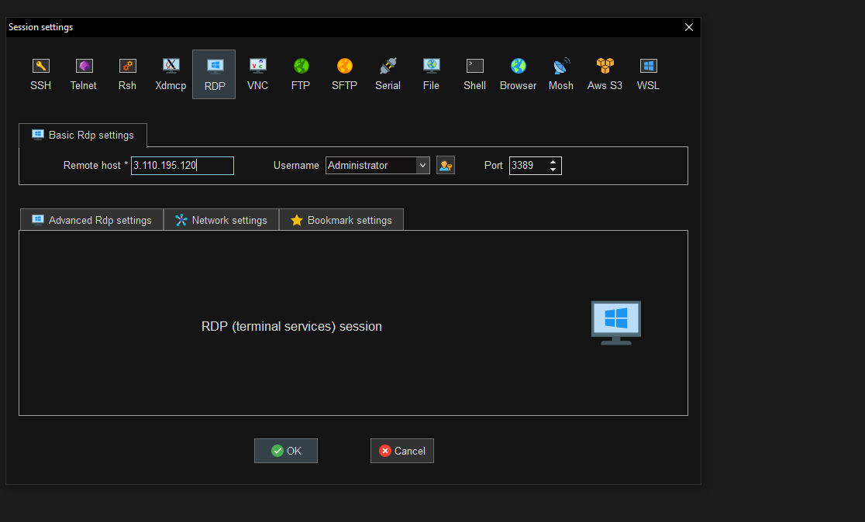

Click on OK after pasting IP address and username .. copy paste the password from the RDP client tab . Click on OK

